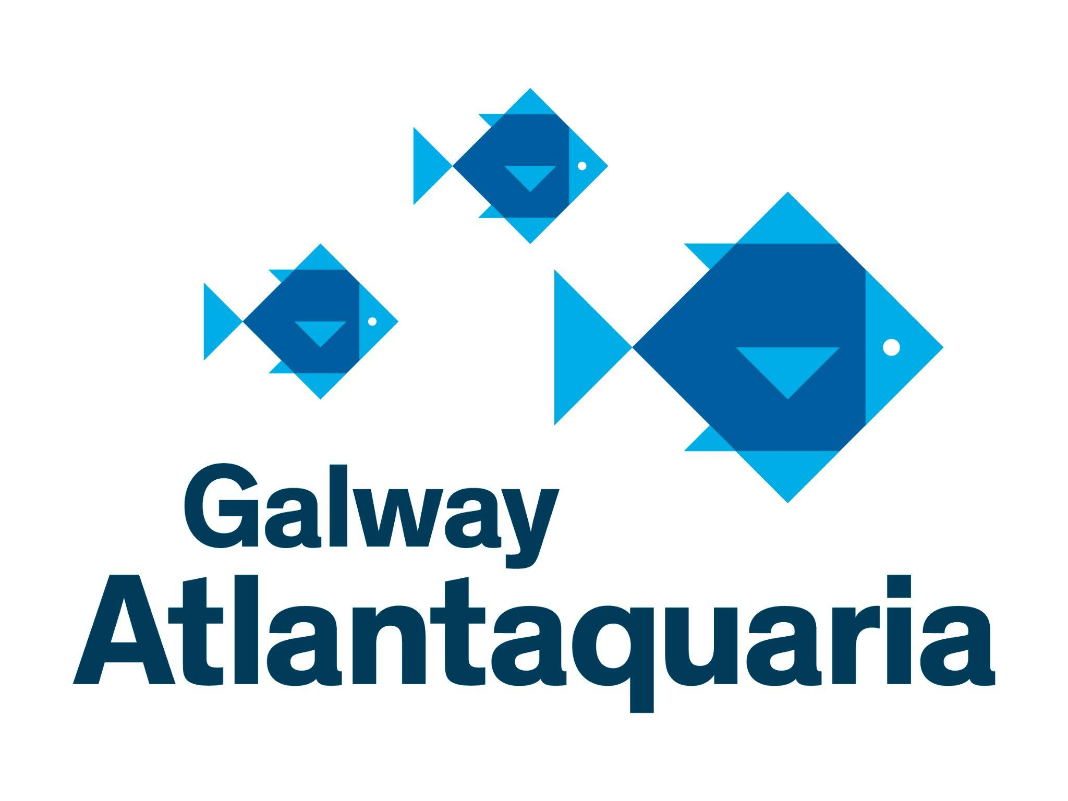
VOLUNTEER ROLE AT GALWAY ATLANTAQUARIA 2026/2027

Mission Statement
Opened in 1999, Galway Atlantaquaria, also known as the National Aquarium of Ireland, has a mission to highlight the world of water to its visitors, with special focus on native species, found in Ireland’s rivers and lakes and in the ocean around the coast.

Aim of volunteering role:
To support the mission of Galway Atlantaquaria. To provide volunteer opportunities for gaining experience and training in science communication, visitor engagement and ocean literacy. To provide opportunities for the aquarium team to pass on valuable skills and knowledge.

The objective of the volunteer role is to:

- Identify opportunities for engaging with visitors, and provide information or opportunities for conversations or interactive experiences based on native species, ecosystems or nature based topics.
- Explore topics with visitors and keep basic records on what topics are of interest to different audience types.
- Suggest ways visitors can connect with local nature, conservation groups or participate in pro-environmental actions.
- Produce a short learning record, and plan for further development.

Tasks:

- Engage with visitors at the information desk at the aquarium.
- Help Galway Atlantaquaria to fulfil its vision and mission and education and conservation strategy.
- Perform the volunteering role to the best of your ability.
- Record general information on visitors areas of interest
- Meet time commitments and standards agreed and to give reasonable notice so other arrangements can be made when this is not possible.
- Maintain any confidential information of the organisation or its clients.
- Not disclose any information to the media and to pass on any enquiries from the media to the Press Officer.
- Read and follow the organisation's procedures and standards, including Health and safety and equal opportunities, in relation to the general public, staff and other volunteers.
- Engage with a Garda Vetting procedure where necessary.

Skills required:
Full training will be provided, but experience or an interest in certain areas would be beneficial as this role will work directly with members of the public.Please note that all volunteers for this role must be aged 18 years or over.

Place of duty:
The main place of duty will be the information desk and rock pool exhibit on the first floor of the aquarium.

Volunteer’s Staff or Point of Contact at the Aquarium
Dr. Noirin Burke, Director of Education and Petra Kerkhove - Administration and Aquarist

GALWAY ATLANTAQUARIA VOLUNTEER INTEREST FORM
Please complete in BLOCK CAPITALS

Please note: If you are shortlisted from your interest form you will be invited to an informal discussion on volunteering at the aquarium

Name…………………………………………………………………………………………………………………………………………………………….
Address……………………………………………………………………………………………………………………………………………………….
………………………………………………………………………………………………………………………………………………………………………
Post Code................................................................ Phone Number……………………………………………………………..
Email.………………………………………………………….......... Mobile Phone Number………………………………………………….
Date of Birth………………………………………………………..

DO YOU HAVE A SKILL, HOBBY OR SPECIAL INTEREST THAT MIGHT BE OF VALUE TO OUR ORGANISATION? E.G. IT LITERATE, ARTIST, PUBLIC SPEAKING:
……………………………………………………………………………………………………………………......................................................................................

………………………………………………………………………………………………………………………………………………………………………………………………………..

ARE YOU A MEMBER OF ANY ANIMAL/CONSERVATION ORGANISATIONS?

(GIVE DETAILS) ……………………………………………………………………………………………………………………………………………………………………………….
………………………………………………………………………………………………………………………………………………………………………………………………………

WHEN WAS THE LAST TIME YOU VISITED GALWAY ATLANTAQUARIA? …………………………………………………………

HOW DO YOU FEEL ABOUT ZOOS AND AQUARIUMS? …………………………………………………………………………………..

………………………………………………………………………………………………………………………………………………………………………

PLEASE LIST PREVIOUS AND / OR CURRENT VOLUNTEER EXPERIENCE
………………………………………………………………………………………………………………………………………………………………………
………………………………………………………………………………………………………………………………………………………………………

HOW DID YOU BECOME AWARE OF THE VOLUNTEER PROGRAMME?
………………………………………………………………………………………………………………………………………………………………………
………………………………………………………………………………………………………………………………………………………………………

DO YOU HAVE ANY EXPERIENCE OR INTEREST IN ANY OF THE FOLLOWING AREAS?
- A qualification or interest in public engagement
- A qualification or interest in freshwater, marine, biological or environmental sciences
- A qualification or interest in national primary and secondary curricula, pre-school curricula or adult education
- A qualification or interest in art or storytelling or design
- Experience of engaging with virtual delivery, evaluation, and social media platform
………………………………………………………………………………………………………………………………………………………………………
………………………………………………………………………………………………………………………………………………………………………
………………………………………………………………………………………………………………………………………………………………………
………………………………………………………………………………………………………………………………………………………………………

PLEASE LET US KNOW WHAT DAYS / TIMES YOU ARE INTERESTED IN VOLUNTEERING

Time: Volunteering will primarily be carried out at weekends and over school holidays. A minimum of two hours per week will be required. Please circle the days you are available, interested in volunteering.

Saturday | yes | no | maybe
Sunday | yes | no | maybe
School Holidays | yes | no | maybe

Please circle if you have a preference for a time of the day?

11am - 1pm | yes | no | maybe
1pm - 3pm | yes | no | maybe
3pm - 5pm | yes | no | maybe

Place of duty:
The main place of duty will be the information desk and rock pool exhibit on the first floor of the aquarium.

Department Manager / Volunteers Staff:
You will report to the manager on the day you are working. You will be notified who this is but your main contacts will be
- Noirin Burke
- Petra Kerkhove
- Matt Hawkins
- Jovita Mockute

Materials required:
Volunteers will be required to make their own way to the aquarium, but can be provided with information about public transport. Suitable clothing and shoes will be required and a branded aquarium top and name badge will be provided.

Any health and safety requirements: Volunteers should notify the aquarium of any specific requirements they may have for mobility or working with the public. Every possible accommodation will be made, while being mindful that volunteers will need to be able to work independently and that the layout and design of the building cannot be altered significantly.

REFERENCES: Please list two referees who may be contacted to provide a reference for you. These references will be taken up if you are successful at your informal discussion and both references must be returned successfully before your induction is arranged and you begin your volunteering with us.

Name: | Name:
Address: | Address:
Postcode: | Postcode:
Email address: | Email address:
HAVE YOU ANY CONVICTIONS (other than spent convictions under the Rehabilitation of Offenders Act 1974)? YES NO
DO YOU HAVE ANY MEDICAL ISSUES THAT WE SHOULD BE MADE AWARE OF? YES NO
(GIVE DETAILS)………………………………………………………………………………………………………………………………………………………………………………
EMERGENCY CONTACT NAME………………………………………………………………………………………………………………………………………………………...
PHONE No………………………………………………….. RELATIONSHIP TO YOU……………………………………………………………………………………………..
I understand that the information I have provided may be verified, if necessary, by contacting persons or organisations named in this application. In signing this interest form, I have agreed that if I am selected to become a volunteer I will be guided by the rules and regulations of XXXX. I confirm that the information I have given on this form is true and correct.

Signature Date
Please return by hand to Reception or by email to info@nationalaquarium.ie with the subject line ‘Volunteer Enquiry’

